Assignment No -: 13

Que 1-: Create union that shows names,cities,ratings of all Customers those with a rating of 200 or greater will also have the words “High Rating” while others will have the words “Low Rating”.

kd2_83598>select Cname,city,'High Rating' Rating from Customers
-> where Rating>200
-> Union
-> select Cname,city,'Low Rating' Rating from Customers
-> where Rating<=200;

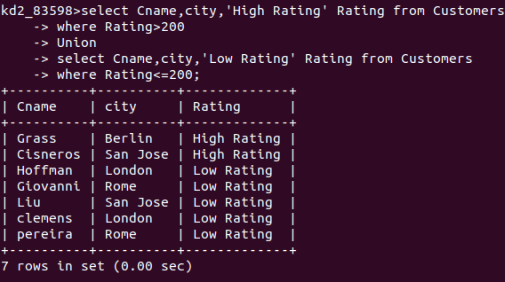

Que 2-: Write A command That Produces the name And Number of each Salesperson and each customer with more than one current order put the results in alphabetical order.

kd2_83598>select Sname,salespeople.Snum,Customers.Cname,Customers.Snum from Customers,salespeople
-> where salespeople.Snum=Customers.Snum and
-> Customers.Cnum in(select orders.Cnum from orders
-> group by Cnum
-> having count(Cnum)>1)
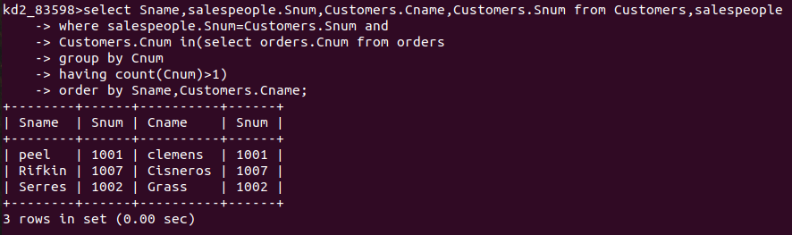
-> order by Sname,Customers.Cname;

Que 3-: form Union of three Queries snum of all salespeople in san jose ,Cnum of all Customers in san jose and third onum of all orders on october 3 Retain duplicates between the last two queries.

kd2_83598>select Snum from salespeople
-> where city='San Jose'
-> union
-> select distinct(snum) from orders
-> where snum in(select snum from orders
-> where odate like '1990-10-03');

